SIMATS ENGINEERING
ASSESSMENT TOOL 2
NAME: DIVYA SHREE.K
REG NO: 192521376

COURSE NAME: COMPUTER NETWORKS
COURSE CODE: CSA07

COURSE OUTCOME COVERED
CO2: Configure IP addressing schemes, subnetting, and basic routing techniques
using simulation tool, for efficient network design and topology. (BL3)
Assessment Tool Weightage: 30%

Annexure A
Scenario-Based

1. A newly established Smart Campus is deploying a secure network
infrastructure for its academic and administrative departments. The network
administrator has been allocated the IP address block 192.168.100.0/24. Based
on the expected number of devices, the following subnet masks have already
been assigned:
School of Computing → /25
School of Electronics → /26
School of Mechanical Engineering → /27
As the network engineer, design the subnet allocation by performing the
following tasks:
1. Determine the network address and broadcast address for each
department.
2. Identify the valid host IP address range for each subnet.
3. Calculate the number of usable host addresses available in each subnet.
4. Determine the remaining unused IP address range within the given
network block.
2. A multinational software company is expanding its headquarters and has been
assigned the private IP block 10.10.0.0/16. Different departments require
different subnet sizes based on the number of employees. The network
administrator has allocated the following subnet masks:
Software Development → /24
Quality Assurance → /25
Human Resources → /26
Executive Management → /27
As the network administrator, perform the following tasks:
1. Determine the network address and broadcast address for each
department.
2. Identify the valid range of host IP addresses.
3. Calculate the number of usable hosts in each subnet.
4. Identify the unused IP address range remaining within the allocated IP
block.
3.A smart hospital is migrating its network infrastructure from IPv4 to IPv6 to
support thousands of connected medical devices and IoT sensors. The hospital
has been assigned the IPv6 network:
2001:0db8:abcd:0000:0000:0000:0000:0000/64
As the network engineer responsible for the migration, perform the following:
1. Convert the given IPv6 address into its compressed notation.
2. Expand the compressed address back into its full hexadecimal
representation.
3. Identify the network prefix using the /64 prefix length.
4. Calculate the total number of host addresses supported within the
subnet.

5. the total number of possible host addresses available within this network.
4. An Internet Service Provider (ISP) connects multiple customer networks
through a core router. The router maintains the following routing table entries:
192.168.1.0/24
192.168.2.0/24
192.168.3.0/24
A packet arrives at the router with the destination IP address:
192.168.2.45
As the routing engineer, determine:
1. The destination subnet to which the packet belongs.
2. The matching routing table entry.
3. The next-hop network/interface used to forward the packet.
4. The default route that should be used if the destination does not match
any routing table entry.
5. A company establishes two office departments connected through a Layer-3
router. The allocated subnet information is as follows:
Administration LAN → 192.168.10.0/26
Finance LAN → 192.168.10.64/26
The router interfaces are configured with:
Administration Gateway → 192.168.10.1
Finance Gateway → 192.168.10.65
As the network administrator, perform the following tasks:
1. Determine the network address and broadcast address for each LAN.
2. Identify the valid host IP address range.
3. Suggest suitable IP addresses for three computers in each LAN.

4. Identify the default gateway that hosts in each LAN should use for
communication.

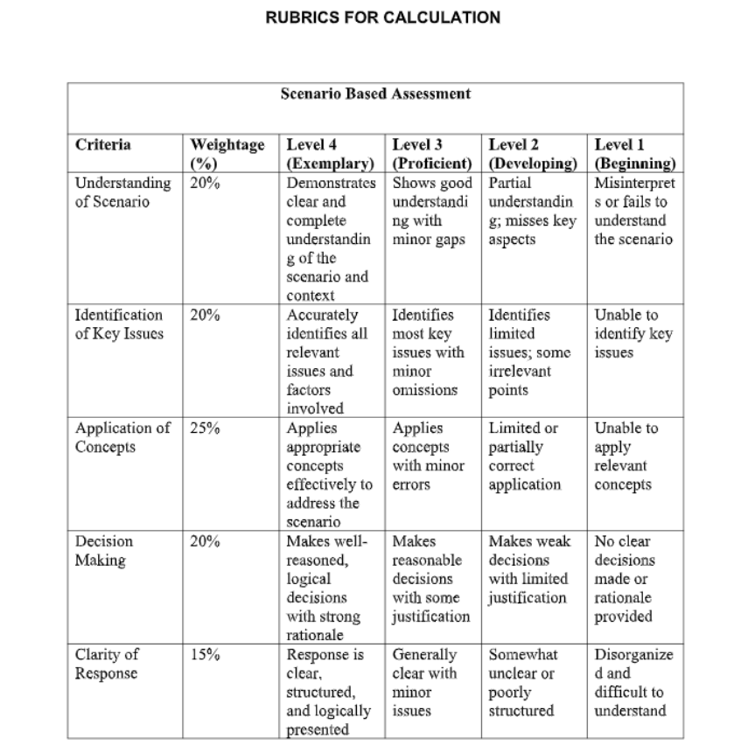

Question 1
Given
IP Address Block = 192.168.20.0/24
Lab A = /26
Lab B = /27
Lab C = /28

Step 1 : Lab A (/26)
Subnet Mask = 255.255.255.192
Block Size
Formula:
Block Size = 256 − Last Octet of Subnet Mask = 256 – 192= 64
Subnet Increment = 0, 64, 128, 192
Network Address = 192.168.20.0
Broadcast Address = Next Network – 1 = 192.168.20.63
Valid Host IP Address Range
First Host = 192.168.20.1
Last Host = 192.168.20.62
Usable Host Addresses Host Bits = 32 – 26 = 6
Total Addresses = 2⁶ = 64
Usable Hosts = 64 – 2 = 62

Step 2 : Lab B (/27)
Next Available Network = 192.168.20.64
Subnet Mask = 255.255.255.224
Block Size
Formula:
Block Size = 256 − Last Octet of Subnet Mask = 256 – 224 = 32
Subnet Increment = 64, 96, 128, 160, 192, 224
Network Address = 192.168.20.64
Broadcast Address = Next Network – 1 = 192.168.20.96 – 1 = 192.168.20.95
Valid Host IP Address Range
First Host = 192.168.20.65
Last Host = 192.168.20.94
Usable Host Addresses
Host Bits = 32 – 27 = 5
Total Addresses = 2⁵ = 32
Usable Hosts = 32 – 2 = 30
Step 3 : Lab C (/28)
Next Available Network = 192.168.20.96
Subnet Mask = 255.255.255.240
Block Size
Formula:
Block Size = 256 − Last Octet of Subnet Mask
= 256 − 240
= 16
Subnet Increment
= 96, 112, 128, 144, 160, 176, 192, 208, 224, 240
Network Address
= 192.168.20.96
Broadcast Address
= Next Network − 1
= 192.168.20.112 − 1
= 192.168.20.111
Valid Host IP Address Range
First Host = 192.168.20.97
Last Host = 192.168.20.110
Usable Host Addresses
Host Bits = 32 − 28
= 4
Total Addresses = 2⁴
= 16
Usable Hosts = 16 − 2
= 14

Answer for Task 1 : Determine the Network Address and Broadcast Address
Lab A
Network Address = 192.168.20.0
Broadcast Address = 192.168.20.63
Lab B
Network Address = 192.168.20.64
Broadcast Address = 192.168.20.95
Lab C
Network Address = 192.168.20.96
Broadcast Address = 192.168.20.111

Answer for Task 2 : Identify the Valid Host IP Address Range
Lab A
First Host = 192.168.20.1
Last Host = 192.168.20.62
Lab B
First Host = 192.168.20.65
Last Host = 192.168.20.94
Lab C
First Host = 192.168.20.97
Last Host = 192.168.20.110

Answer for Task 3 : Calculate the Number of Usable Host Addresses
Lab A
Usable Hosts = 62
Lab B
Usable Hosts = 30
Lab C
Usable Hosts = 14

Question 2
Given
System 1 IP Address = 192.168.1.130
System 2 IP Address = 192.168.1.190
Subnet Mask = 255.255.255.192 (/26)

Step 1 : Find the Block Size
Subnet Mask = 255.255.255.192
Block Size
Formula:
Block Size = 256 − Last Octet of Subnet Mask
= 256 − 192
= 64
Subnet Increment
= 0, 64, 128, 192
The subnet ranges are:
- 192.168.1.0 – 192.168.1.63
- 192.168.1.64 – 192.168.1.127
- 192.168.1.128 – 192.168.1.191
- 192.168.1.192 – 192.168.1.255

Step 2 : Determine the Subnet for System 1
IP Address = 192.168.1.130
192.168.1.130 lies between 192.168.1.128 and 192.168.1.191
Network Address
= 192.168.1.128
Broadcast Address
= 192.168.1.191
Valid Host IP Address Range
First Host = 192.168.1.129
Last Host = 192.168.1.190
Check the Given IP Address
192.168.1.130 lies between
192.168.1.129 and 192.168.1.190
Therefore,
192.168.1.130 belongs to this subnet.

Step 3 : Determine the Subnet for System 2
IP Address = 192.168.1.190
192.168.1.190 lies between 192.168.1.128 and 192.168.1.191
Network Address
= 192.168.1.128
Broadcast Address
= 192.168.1.191
Valid Host IP Address Range
First Host = 192.168.1.129
Last Host = 192.168.1.190
Check the Given IP Address
192.168.1.190 lies between
192.168.1.129 and 192.168.1.190
Therefore,
192.168.1.190 belongs to this subnet.

Step 4 : Calculate the Number of Usable Host Addresses
Host Bits
= 32 − 26
= 6
Total Addresses
= 2⁶
= 64
Usable Hosts
= 64 − 2
= 62

Answer for Task 1 : Determine the Network Address and Broadcast Address
System 1
Network Address = 192.168.1.128
Broadcast Address = 192.168.1.191
System 2
Network Address = 192.168.1.128
Broadcast Address = 192.168.1.191
Answer for Task 2 : Identify the Valid Host IP Address Range
System 1
First Host = 192.168.1.129
Last Host = 192.168.1.190
System 2
First Host = 192.168.1.129
Last Host = 192.168.1.190

Answer for Task 3 : Verify Whether the IP Addresses Belong to the Subnet
System 1
192.168.1.130 belongs to the subnet 192.168.1.128/26.
System 2
192.168.1.190 belongs to the subnet 192.168.1.128/26.

Answer for Task 4 : Number of Usable Host Addresses
Usable Hosts = 62

Question 3
Given
IP Address Block = 172.16.0.0/16
HR Department = /25
Sales Department = /26
IT Department = /27
Admin Department = /28

Step 1 : HR Department (/25)
Subnet Mask = 255.255.255.128
Block Size
Formula:
Block Size = 256 − Last Octet of Subnet Mask
= 256 − 128
= 128
Network Address
= 172.16.0.0
Broadcast Address
= Next Network − 1
= 172.16.0.128 − 1
= 172.16.0.127
Valid Host IP Address Range
First Host = 172.16.0.1
Last Host = 172.16.0.126
Usable Host Addresses
Host Bits = 32 − 25
= 7
Total Addresses = 2⁷
= 128
Usable Hosts = 128 − 2
= 126

Step 2 : Sales Department (/26)
Next Available Network = 172.16.0.128
Subnet Mask = 255.255.255.192
Block Size
= 256 − 192
= 64
Network Address
= 172.16.0.128
Broadcast Address
= Next Network − 1
= 172.16.0.192 − 1
= 172.16.0.191
Valid Host IP Address Range
First Host = 172.16.0.129
Last Host = 172.16.0.190
Usable Host Addresses
Host Bits = 32 − 26
= 6
Total Addresses = 2⁶
= 64
Usable Hosts = 64 − 2
= 62

Step 3 : IT Department (/27)
Next Available Network = 172.16.0.192
Subnet Mask = 255.255.255.224
Block Size
= 256 − 224
= 32
Network Address
= 172.16.0.192
Broadcast Address
= Next Network − 1
= 172.16.0.224 − 1
= 172.16.0.223
Valid Host IP Address Range
First Host = 172.16.0.193
Last Host = 172.16.0.222
Usable Host Addresses
Host Bits = 32 − 27
= 5
Total Addresses = 2⁵
= 32
Usable Hosts = 32 − 2
= 30

Step 4 : Admin Department (/28)
Next Available Network = 172.16.0.224
Subnet Mask = 255.255.255.240
Block Size
= 256 − 240
= 16
Network Address
= 172.16.0.224
Broadcast Address
= Next Network − 1
= 172.16.0.240 − 1
= 172.16.0.239
Valid Host IP Address Range
First Host = 172.16.0.225
Last Host = 172.16.0.238
Usable Host Addresses
Host Bits = 32 − 28
= 4
Total Addresses = 2⁴
= 16
Usable Hosts = 16 − 2
= 14

Step 5 : Remaining Unused IP Address Range
HR Department
= 172.16.0.0 – 172.16.0.127
Sales Department
= 172.16.0.128 – 172.16.0.191
IT Department
= 172.16.0.192 – 172.16.0.223
Admin Department
= 172.16.0.224 – 172.16.0.239
Remaining Unused IP Address Range
= 172.16.0.240 – 172.16.255.255
Answer for Task 1 : Determine the Network Address and Broadcast Address
HR
Network Address = 172.16.0.0
Broadcast Address = 172.16.0.127
Sales
Network Address = 172.16.0.128
Broadcast Address = 172.16.0.191
IT
Network Address = 172.16.0.192
Broadcast Address = 172.16.0.223
Admin
Network Address = 172.16.0.224
Broadcast Address = 172.16.0.239

Answer for Task 2 : Identify the Valid Host IP Address Range
HR
First Host = 172.16.0.1
Last Host = 172.16.0.126
Sales
First Host = 172.16.0.129
Last Host = 172.16.0.190
IT
First Host = 172.16.0.193
Last Host = 172.16.0.222
Admin
First Host = 172.16.0.225
Last Host = 172.16.0.238

Answer for Task 3 : Calculate the Number of Usable Host Addresses
HR = 126
Sales = 62
IT = 30
Admin = 14
Answer for Task 4 : Remaining Unused IP Address Range
172.16.0.240 – 172.16.255.255
4 and 5
Question 4
Given
Network Address = 172.16.10.0/24
Subnet Mask = /27
IP Address 1 = 172.16.10.78
IP Address 2 = 172.16.10.95

Step 1 : Find the Subnet Mask
Subnet Mask
= 255.255.255.224
Step 2 : Calculate the Block Size
Formula:
Block Size = 256 − Last Octet of Subnet Mask
= 256 − 224
= 32
Subnet Increment
= 0, 32, 64, 96, 128, 160, 192, 224
Step 3 : Calculate the Total Number of Subnets
Original Prefix
= /24
New Prefix
= /27
Borrowed Bits
= 27 − 24
= 3
Formula:
Total Subnets = 2^(Borrowed Bits)
= 2³
= 8 Subnets

Step 4 : Calculate the Number of Usable Hosts
Host Bits
= 32 − 27
= 5
Total Addresses
= 2⁵
= 32
Usable Hosts
= 32 − 2
= 30 Hosts
Step 5 : Determine the Subnet for IP Address 172.16.10.78
The subnet ranges are:
172.16.10.0 – 172.16.10.31
172.16.10.32 – 172.16.10.63
172.16.10.64 – 172.16.10.95
172.16.10.96 – 172.16.10.127
Since 172.16.10.78 lies between 172.16.10.64 and 172.16.10.95,
Network Address
= 172.16.10.64
Broadcast Address
= 172.16.10.95
Valid Host IP Address Range
First Host = 172.16.10.65
Last Host = 172.16.10.94

Step 6 : Verify Whether 172.16.10.95 Belongs to the Same Subnet
Given IP Address
= 172.16.10.95
172.16.10.95 is equal to the Broadcast Address of the subnet.
Therefore,
172.16.10.95 belongs to the same subnet, but it cannot be assigned to any host because it is the Broadcast Address.

Answer for Task 1 : Total Number of Subnets
Total Subnets = 8

Answer for Task 2 : Number of Usable Hosts per Subnet
Usable Hosts = 30

Answer for Task 3 : Determine the Subnet for 172.16.10.78
Network Address = 172.16.10.64
Broadcast Address = 172.16.10.95
Valid Host Range = 172.16.10.65 – 172.16.10.94

Answer for Task 4 : Verify 172.16.10.95
172.16.10.95 belongs to the same subnet, but it is the Broadcast Address and cannot be assigned to a host.

Question 5
Given
IPv6 Address
= 2001:0db8:0000:0000:0000:ff00:0042:8329
Prefix Length
= /64

Step 1 : Compress the IPv6 Address
Rule 1
Remove the leading zeros from each block.
2001:0db8:0000:0000:0000:ff00:0042:8329
↓
2001:db8:0:0:0:ff00:42:8329
Rule 2
Replace consecutive blocks of 0 with :: (only once).
Compressed IPv6 Address
= 2001:db8::ff00:42:8329

Step 2 : Expand the Compressed IPv6 Address
Compressed Address
= 2001:db8::ff00:42:8329
Replace :: with three missing 0000 blocks.
Expanded IPv6 Address
= 2001:0db8:0000:0000:0000:ff00:0042:8329

Step 3 : Determine the Network Prefix
Prefix Length
= /64
The first 64 bits (first four hexadecimal blocks) represent the network.
Network Prefix
= 2001:0db8:0000:0000::/64
Compressed Form
= 2001:db8::/64

Step 4 : Calculate the Number of Host Bits
IPv6 Address Length
= 128 bits
Prefix Length
= 64 bits
Host Bits
= 128 − 64
= 64 bits

Step 5 : Calculate the Total Number of Host Addresses
Formula:
Total Host Addresses = 2^(Host Bits)
= 2⁶⁴
= 18,446,744,073,709,551,616
Approximately
= 18.4 Quintillion Host Addresses
Answer for Task 1 : Compressed IPv6 Address
2001:db8::ff00:42:8329
Answer for Task 2 : Expanded IPv6 Address
2001:0db8:0000:0000:0000:ff00:0042:8329
Answer for Task 3 : Network Prefix
2001:0db8:0000:0000::/64
(Compressed Form: 2001:db8::/64)
Answer for Task 4 : Total Number of Host Bits
64 Bits
Answer for Task 5 : Total Number of Possible Host Addresses
2⁶⁴ = 18,446,744,073,709,551,616 (Approximately 18.4 Quintillion Host Addresses)

